HR Replacement-New joinee Project Form

Select option: 1) Replacement
2) New joinee

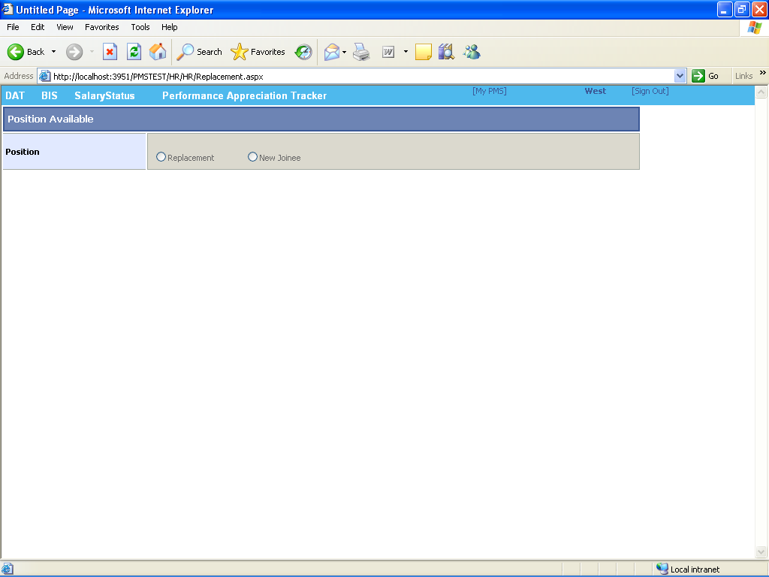

If you selecting the replacement option in position replacement form is opened.

Steps:
1) first enter Employee code and click on search button then all detail respective employee code is come like location,designation,unit,employee name,address

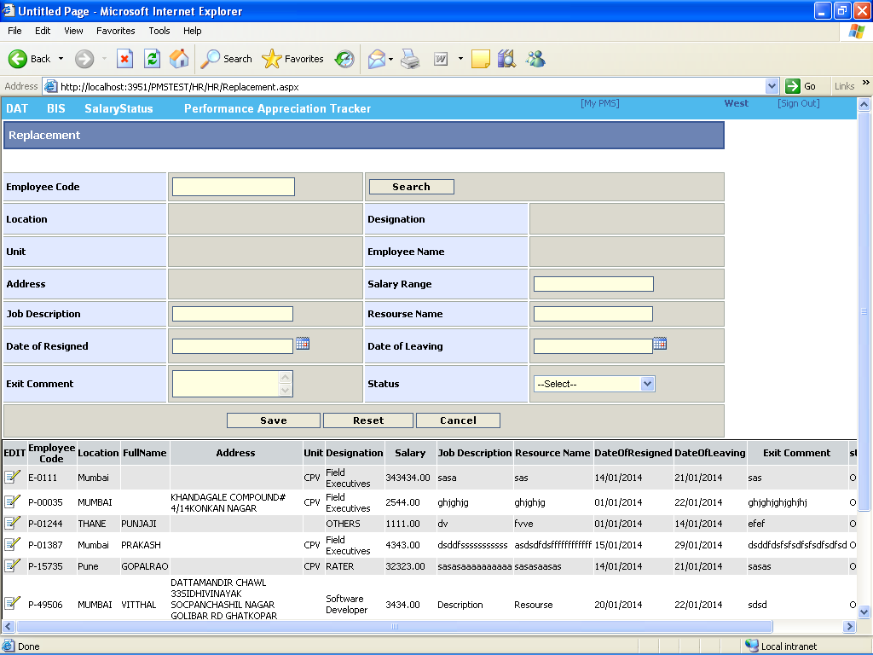

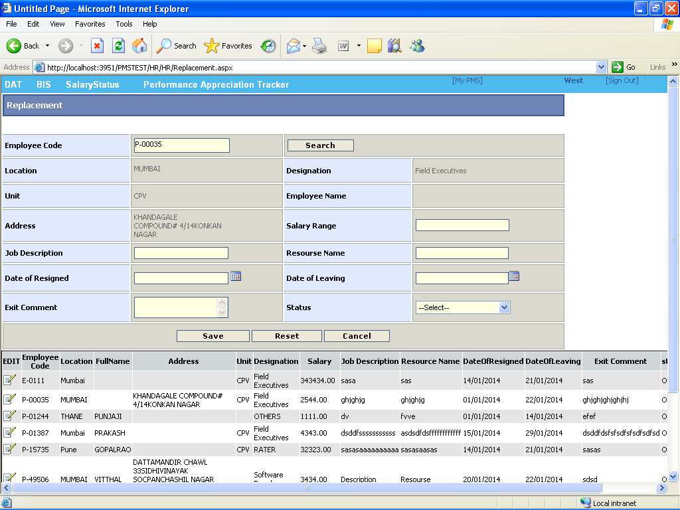

2) insert all the details against that employee code in replacement form like salary range,job description,resourse name,date of resigned , date of leaving,exit comment and status .
3)click save option for submitting data.
4) if you want to reset given information then click reset option .
5)for canceling process select cancel option and go to main menu master.

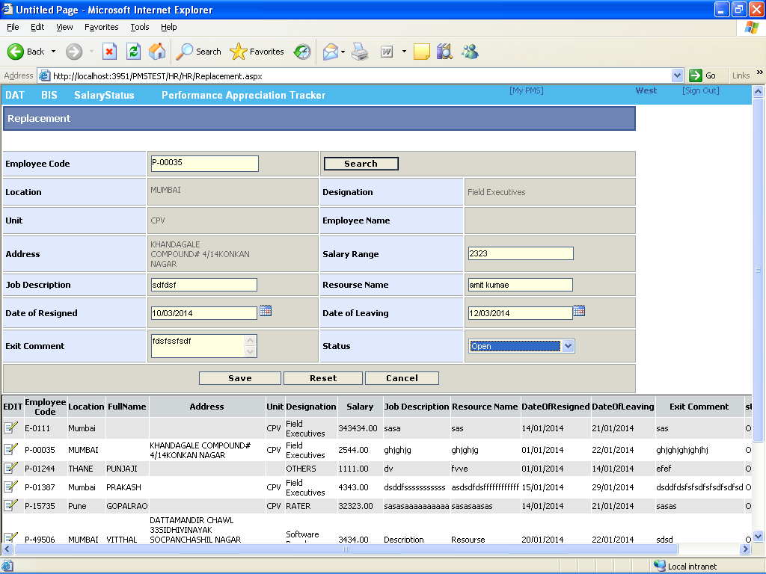

Steps for the new joinee form
Step :
1) If process for the new joinee then enter the following details
a)Requirement
b)Designation.
c)Job description
d)Remark
e)Resource name
f) date of joining
g)status.

2) after inserting all details save all details

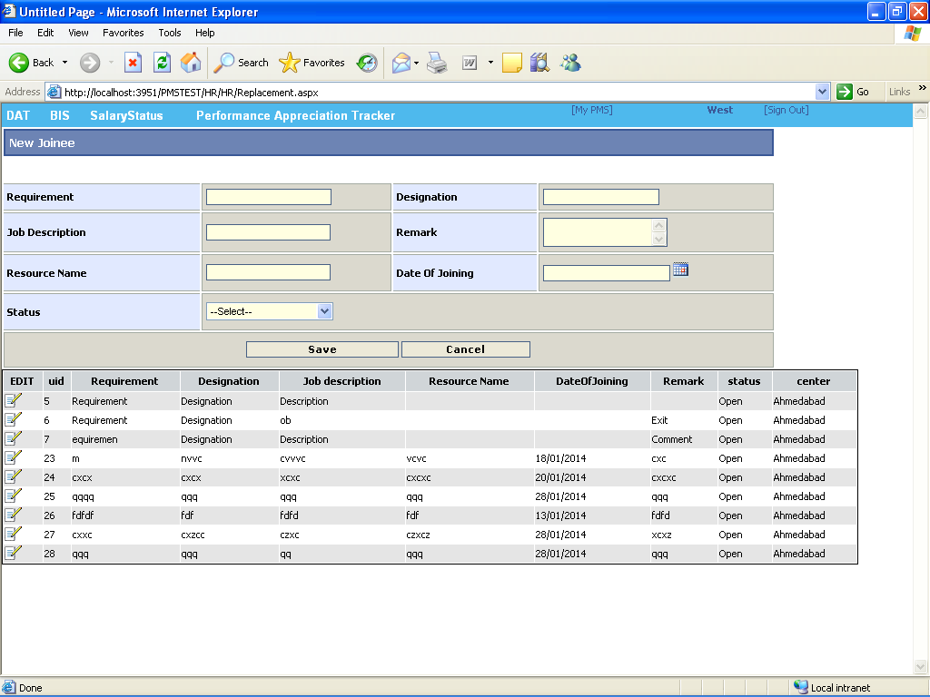

If u want to edit previous data then edit option also provide for updating details

